Annex 2f -Technical Offer Form
This form must be completed separately for each product's strength and pack size of the products you are offering to UNICEF.
To access and complete the form, please use the links provided below
Links:
- URL:
UNICEF Technical Offer Form-Annex 2f RFP-DAN-2026-503918-Injectable and Critical Care Med. – Fill out form

Or
- QR code
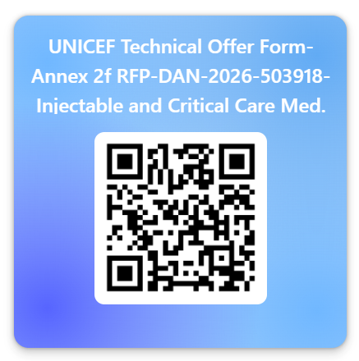

Please assure to submit a completed and signed Annex 2g UNICEF Technical commitment declaration form as part of the technical proposal along with each submitted Annex 2f -Technical Offer Form
Annex 2g UNICEF Technical commitment declaration form and other relevant documents (CoA, artworks...) must be uploaded to SharePoint library as described in RFP document.

