Annex 2f -Abridged Finished Pharmaceutical Product Questionnaire
This form must be completed separately for each product's strength and pack size of the products you are offering to UNICEF.
To access and complete the form, please use the links provided below:
Links:
- URL:
- Window 1: RFP-DAN-2026-503933 window 1 Annex 2f: Abridged Finished Pharmaceutical Product Qn** – Fill out form

- Window 2: RFP-DAN-2026-503933 window 2 Annex 2f: Abridged Finished Pharmaceutical Product Qn** – Fill out form
Or
- QR code
- Window 1
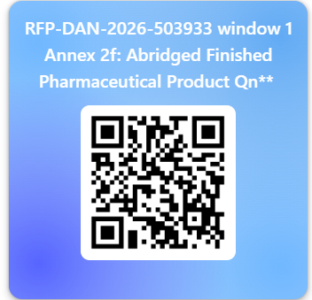
- Window 2
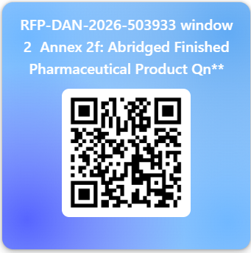
Next steps:
After completing Annex 2f (Abridged Finished Pharmaceutical Product Questionnaire), proposers shall request for access to their designated SharePoint folder by sending an email to Rennie Shonhiwa-Chikwanha at rshonhiwa@unicef.org
Once access is granted, proposers must upload the following documents, which are an integral part of the technical proposal submission:
- Signed Annex 2g – UNICEF Technical Commitment Declaration
- Certificate(s) of Analysis for the most recently manufactured batch(es)
- Certificate of Pharmaceutical Product (CPP) issued in accordance with the WHO Certification Scheme
- Summary of Product Characteristics (SmPC) and package insert
- Artwork for primary and secondary packaging
- Photographs of the commercial product: Carton (all sides); - Blister, ampoule, vial, bag, tube, or bottle (as applicable); Measuring device (if applicable) and Patient Information Leaflet (PIL) or package insert.
Proposers are responsible for ensuring that all documents are complete, current, and uploaded within the timelines specified in the RFP.

